Dynamic Incentive Structures and Transformer-Based Competency Mapping for Innovation Talent Evaluation in Development Programs

Xinyu Cai, Xiaoxue Chen

( College of Business, Jiaxing University, Jiaxing, Zhejiang 314001, China )

[1]

**Abstract**—This research propose a dynamic incentive framework integrated with transformer-based competency mapping to address the limitations of static talent evaluation systems in development programs. The core innovation lies in the Adaptive Incentive Engine (AIE), which dynamically adjusts rewards based on real-time performance metrics, skill progression, and peer-relative benchmarks, thereby fostering sustained engagement and alignment with developmental goals. The system employs a dual-layer evaluation mechanism, where a transformer-based model processes multi-modal inputs to generate high-dimensional skill embeddings, while a feedback adoption layer delivers contextual nudges to participants exhibiting suboptimal progress. Furthermore, the AIE replaces conventional static reward structures by modulating resource allocation and prioritizing high-performing individuals for advanced opportunities. The implementation leverages fine-tuned RoBERTa-large models for competency mapping and a distributed reinforcement learning framework for adaptive weight calibration, ensuring scalability across large participant cohorts. Unlike traditional rubric-based approaches, our method captures nuanced skill evolution through latent space representations and hybrid nudge delivery, combining digital and institutional channels to reinforce behavioral change. The proposed framework demonstrates significant potential to enhance talent development outcomes by bridging the gap between quantitative metrics and qualitative assessments, offering a responsive and data-driven alternative to existing evaluation paradigms.

**Index Terms**—Dynamic incentive structures, Transformer-based competency mapping, Innovation talent evaluation, Reinforcement learning, Behavioral nudges

# I. INTRODUCTION

The evaluation of innovation talent has become a critical challenge for organizations and regions pursuing sustainable development through human capital optimization. Traditional assessment systems often rely on static rubrics and periodic reviews, which fail to capture the dynamic nature of skill acquisition and innovation potential [1]. This limitation becomes particularly evident in rapidly evolving sectors such as technology-driven regional development programs, where the mismatch between evaluation mechanisms and actual competency growth can hinder talent cultivation efforts [2].

Recent advances in behavioral economics and machine learning offer promising avenues to address these shortcomings. Behavioral insights demonstrate that dynamic incentive structures significantly outperform fixed reward systems in sustaining engagement and skill development [3]. Meanwhile, transformer-based models have shown remarkable capabilities in mapping complex competency trajectories from heterogeneous performance data [4]. Despite these technological opportunities, most existing talent evaluation frameworks remain siloed, either focusing narrowly on quantitative metrics or relying on subjective qualitative assessments without systematic integration [5].

The proposed system introduces three key innovations to bridge this gap. First, it establishes a closed-loop feedback mechanism where evaluation outcomes directly influence incentive structures through adaptive algorithms. This approach differs fundamentally from conventional systems by creating a responsive relationship between demonstrated competencies and reward opportunities [6]. Second, the framework implements a dual-path evaluation process that combines AI-driven competency mapping with behavioral nudges, addressing both the cognitive and motivational dimensions of talent development [7]. Third, the system incorporates regional innovation ecosystem characteristics into its weighting mechanisms, enabling context-sensitive assessments that reflect local development priorities [8].

Several critical challenges motivate this research. Static evaluation systems often create perverse incentives, where participants optimize for measurable but superficial indicators rather than genuine competency growth [9]. Moreover, traditional approaches struggle to accommodate the nonlinear progression patterns characteristic of innovation skills, frequently misclassifying transitional performance dips as competence deficits [10]. These limitations become particularly acute in regional development contexts like Zhejiang Province, where rapid technological transformation demands evaluation systems capable of tracking emergent skills and adapting to shifting economic priorities [11].

Our work makes four primary contributions. We develop a novel dynamic incentive engine that automatically adjusts reward structures based on real-time performance trajectories and peer cohort comparisons. The system introduces a transformer-based competency mapping architecture that processes multi-modal evaluation data to generate high-dimensional skill representations. We demonstrate how institutional nudges can be systematically integrated with digital feedback mechanisms to reinforce positive behavioral change. Finally, we provide a scalable implementation framework that addresses the practical constraints of large-scale talent development programs.

The remainder of this paper is organized as follows: Section 2 reviews related work in talent evaluation systems and behavioral intervention mechanisms. Section 3 presents the theoretical foundations and system architecture. Section 4 details the implementation of the dynamic evaluation framework. Section 5 discusses empirical validation results, followed by implications and future research directions in Section 6.

# II. Literature Review

The development of effective talent evaluation systems intersects multiple research domains, including behavioral economics, competency modeling, and adaptive learning systems. Existing approaches can be broadly categorized into three perspectives: incentive structure design, skill assessment methodologies, and feedback mechanisms in organizational contexts.

## A. Behavioral Foundations of Incentive Systems

Traditional talent management systems often employ static reward structures based on periodic performance reviews [12]. However, research in behavioral economics demonstrates that dynamic incentive mechanisms grounded in reinforcement learning principles yield superior engagement outcomes [13]. The concept of adaptive rewards has been particularly effective in educational settings, where variable reinforcement schedules maintain motivation better than fixed-interval systems [14]. Recent work has extended these principles to organizational talent development, showing that real-time performance adjustments can mitigate the common problem of evaluation gaming [15]. Our proposed Adaptive Incentive Engine builds upon these findings while introducing novel computational methods for weight optimization.

## B. Competency Modeling and Assessment

Modern talent evaluation systems increasingly incorporate machine learning techniques to overcome the limitations of rubric-based assessments. Transformer architectures have shown particular promise in processing heterogeneous competency data, from project deliverables to peer evaluations [16]. Unlike traditional factor analysis approaches, these models capture nonlinear skill interactions through high-dimensional embeddings [17]. The literature also highlights the importance of contextual adaptation in competency frameworks, as rigid assessment criteria often fail to accommodate regional innovation ecosystem characteristics [18]. Our competency mapper addresses this gap by integrating domain-specific fine-tuning with dynamic weighting mechanisms.

## C. Feedback Delivery and Institutional Nudges

Effective talent development requires not just accurate assessment but also mechanisms to translate feedback into behavioral change. Research in organizational psychology demonstrates that hybrid nudge systems combining digital prompts with institutional reinforcement achieve higher adoption rates than either approach alone [19]. The timing and framing of feedback also prove critical, with context-sensitive interventions outperforming generic recommendations [20]. Our dual-layer evaluation mechanism operationalizes these insights through a celery-based task queue that triggers nudges based on real-time engagement metrics.

The proposed system advances beyond existing approaches through three key innovations. First, it integrates dynamic incentive calibration with high-dimensional competency mapping, addressing the rigidity of traditional evaluation frameworks. Second, the architecture combines algorithmic assessment with behavioral intervention strategies, creating a closed-loop talent development ecosystem. Third, the implementation specifically accommodates regional innovation system characteristics through domain-adaptive weighting mechanisms, unlike generic talent management solutions. These advancements enable more responsive and context-aware evaluation compared to conventional static systems.

# III. Theoretical Framework and Background

To establish the foundation for our proposed system, we examine three key theoretical domains that inform our approach: talent development assessment methodologies, reinforcement learning principles for adaptive systems, and natural language processing applications in competency evaluation. These interconnected areas provide the conceptual scaffolding for designing dynamic, data-driven talent evaluation frameworks.

## A. Background on Talent Development and Assessment

Contemporary talent assessment systems face fundamental limitations in capturing the nonlinear progression of innovation competencies. Traditional approaches rely on periodic evaluations using static rubrics, which can be represented through simplified linear models:

$$I_{t}=α⋅S_{t}+β⋅ΔP_{t}+γ⋅R_{peer} (1)$$

where $I_{t}$ denotes the incentive score at time $t$, $S_{t}$ represents static skill assessments, $ΔP_{t}$ indicates performance changes, and $R_{peer}$ reflects peer-relative rankings. While such models provide tractable evaluation mechanisms, they fail to account for complex skill interactions and context-dependent competency manifestations [[21]](https://onlinelibrary.wiley.com/doi/abs/10.1002/hrm.21972). Research in organizational psychology demonstrates that innovation talent development follows discontinuous growth patterns, with critical transition periods where conventional metrics may misrepresent actual competency levels [[22]](https://psycnet.apa.org/record/2018-59444-002). These findings necessitate more sophisticated assessment frameworks capable of tracking multidimensional skill trajectories.

## B. Foundations of Reinforcement Learning and Adaptive Systems

Reinforcement learning offers a principled approach for designing responsive evaluation systems through its formalization of state-action-reward dynamics. The policy gradient theorem provides the mathematical foundation for adaptive weight calibration in our incentive engine:

$$∇_{θ}J\left(θ\right)=E_{t}\left[∇_{θ}logπ_{θ}\left(a_{t}|s_{t}\right)A_{t}\right] (2)$$

where $θ$ represents the policy parameters, $π_{θ}$ denotes the action selection policy, and $A_{t}$ is the advantage function estimating the relative value of actions [[10]](https://pmc.ncbi.nlm.nih.gov/articles/PMC2645553/pdf/HJFOA5-000001-000030_1.pdf). Algorithms like Proximal Policy Optimization (PPO) have proven particularly effective in balancing exploration and exploitation in dynamic environments, making them suitable for talent development contexts where evaluation criteria must adapt to emerging competencies [[23]](https://arxiv.org/pdf/1707.06347). The theoretical framework suggests that adaptive systems can outperform static models by continuously aligning incentives with demonstrated skill progression patterns.

## C. Natural Language Processing for Competency Assessment

Transformer-based models have revolutionized the processing of unstructured evaluation data through their capacity to generate contextualized representations. The core scoring mechanism in our competency mapper builds upon the attention-weighted feature extraction:

$$S_{t}=w^{T}v_{t}+b (3)$$

where $v_{t}$ represents the contextual embedding vector and $w$ denotes the learned weight parameters [[24]](https://www.researchgate.net/profile/Henry-Nunoo-Mensah/publication/348740926_Transformer_Models_for_Text-based_Emotion_Detection_A_Review_of_BERT-based_Approaches/links/600e5ef145851553a06b0ac4/Transformer-Models-for-Text-based-Emotion-Detection-A-Review-of-BERT-based-Approaches.pdf). Models like RoBERTa-large leverage massive pretraining on diverse corpora to develop nuanced understanding capabilities that can be fine-tuned for specific assessment domains [[25]](https://aclanthology.org/2021.naacl-srw.12.pdf). This architecture enables the system to process heterogeneous inputs—from project documentation to peer feedback—while maintaining sensitivity to subtle competency indicators that traditional evaluation methods often overlook. The theoretical foundations demonstrate how modern NLP techniques can bridge the gap between qualitative assessment data and quantitative evaluation frameworks.

# IV. Design of the Behavior-Driven Innovation Talent Evaluation System

The proposed system architecture integrates three core components: a transformer-based competency mapper, a reinforcement learning-driven incentive engine, and a distributed nudge delivery framework. These elements form a closed-loop evaluation ecosystem where skill assessments dynamically influence incentive structures while behavioral interventions reinforce positive developmental patterns.

## A. Configuration and Operation of the Competency Mapper

The competency mapper processes multi-modal evaluation inputs through a fine-tuned RoBERTa-large model to generate dense skill representations. The model architecture employs a gating mechanism to balance qualitative and quantitative assessment components:

$$v_{t}=σ\left(W_{q}q_{t}\right)⊙v_{t}^{qual}+\left(1−σ\left(W_{q}q_{t}\right)\right)⊙v_{t}^{quant} (4)$$

where $v_{t}^{qual}$ denotes qualitative feature vectors extracted from textual feedback, $v_{t}^{quant}$ represents normalized performance metrics, and $W_{q}$ is a learned projection matrix that determines the relative weighting of each modality. The sigmoid gate $σ\left(⋅\right)$ enables adaptive blending of information sources based on input characteristics. This hybrid approach addresses the limitations of purely quantitative scoring rubrics while maintaining the objectivity benefits of metric-based evaluation.

The competency mapper outputs are calibrated against domain-specific benchmarks through a multi-task learning objective:

$$ℒ=λ_{1}ℒ_{skill}+λ_{2}ℒ_{domain}+λ_{3}ℒ_{temporal} (5)$$

where $ℒ_{skill}$ measures prediction error against expert evaluations, $ℒ_{domain}$ ensures alignment with regional innovation priorities, and $ℒ_{temporal}$ enforces consistency with historical performance trajectories. The loss weights $λ_{i}$ are optimized via grid search to balance task-specific objectives. This configuration enables the system to generate context-sensitive assessments that reflect both individual competency profiles and ecosystem-level talent development needs.

## B. Integration of the Dynamic Incentive Engine with Competency Assessment

The Adaptive Incentive Engine (AIE) translates competency mapper outputs into real-time reward adjustments using a Proximal Policy Optimization (PPO) algorithm. The reward function incorporates three key dimensions:

$$r_{t}=α_{t}⋅ΔS_{t}+β_{t}⋅C_{t}+γ_{t}⋅D_{t} (6)$$

where $ΔS_{t}$ measures skill progression, $C_{t}$ represents peer cohort comparison metrics, and $D_{t}$ quantifies domain-specific contribution impact. The dynamic coefficients $α_{t},β_{t},γ_{t}$ are adjusted through the PPO policy gradient updates to maintain optimal engagement levels while preventing incentive gaming behaviors.

The AIE maintains a continuous interaction loop with the competency mapper through a state representation vector:

$$s_{t}=\left[v_{t},Δv_{t},h_{t}\right] (7)$$

where $h_{t}$ encodes historical engagement patterns. This rich state representation enables the system to differentiate between genuine skill development and superficial performance optimization strategies. The policy network $π_{θ}\left(a_{t}|s_{t}\right)$ outputs multi-dimensional action vectors specifying reward allocations, opportunity prioritizations, and developmental resource distributions. Figure 1 provides a comprehensive overview of this integrated framework, illustrating the interconnections between the competency mapper, dynamic incentive engine, and nudge delivery system within the overall talent evaluation architecture.

**Fig. 1** Overview of the Enhanced Talent Assessment and Development Framework.

## C. System Infrastructure for Real-Time Updates and Nudge Delivery

The operational framework leverages a distributed architecture to support scalable real-time processing. The Ray RLlib implementation handles parallel policy updates across worker nodes, with a centralized parameter server synchronizing model weights every $k$ iterations. This design enables near-linear scaling with participant cohort size while maintaining sub-second latency for incentive recalculations.

Nudge delivery is managed through a Celery-based task queue that processes trigger events from the AIE’s anomaly detection module. The nudge generation logic follows:

$$N_{t}=I\left(ΔS_{t}<θ\right)⋅f\left(v_{t},h_{t}\right) (8)$$

where $I\left(⋅\right)$ is an indicator function for suboptimal progress thresholds, and $f\left(⋅\right)$ generates personalized intervention content based on competency profiles and engagement histories. The system supports multi-channel delivery through pluggable adapters for SMS, email, and in-platform notifications, with delivery timing optimized using survival analysis models of previous response patterns.

The complete system architecture demonstrates how modern machine learning techniques can operationalize behavioral science principles in talent development contexts. By combining high-dimensional competency assessment with adaptive incentive structures and context-aware interventions, the framework addresses critical limitations of conventional evaluation systems while maintaining scalability for regional implementation.

# V. Empirical Evaluation

To validate the effectiveness of the proposed behavior-driven innovation talent evaluation system, we conducted comprehensive experiments across multiple dimensions: competency mapping accuracy, incentive structure responsiveness, and nudge intervention efficacy. The evaluation framework incorporates both quantitative metrics and qualitative assessments from domain experts.

## A. Experimental Setup

The evaluation utilized a longitudinal dataset comprising 2,347 participants from regional innovation programs in Zhejiang Province, spanning 18 months of development activities. Each participant contributed multiple data modalities including project deliverables (textual reports, code repositories), peer evaluations, mentor feedback, and performance metrics. The dataset was partitioned temporally, with the first 12 months for model training and the remaining 6 months for validation and testing.

We compared our system against three established approaches:

* 1. **Static Rubric Evaluation (SRE)**

A conventional scoring system using predefined competency dimensions and fixed weights [26].

* 1. **Adaptive Linear Model (ALM)**

A machine learning approach that adjusts feature weights based on performance trends [27].

* 1. **Transformer Baseline (TB)**

A RoBERTa-based classifier without the dynamic gating mechanism or incentive integration [28].

Evaluation metrics included:

* 1. **Skill Prediction Accuracy**

F1-score against expert evaluations.

* 1. **Engagement Sustainability**

Participant activity persistence over time.

* 1. **Developmental Progression**

Measured improvement in core competencies.

* 1. **Nudge Responsiveness**

Rate of positive behavioral change following interventions.

## B. Competency Mapping Performance

The transformer-based competency mapper demonstrated superior skill assessment capabilities compared to baseline methods. As shown in Table 1, our model achieved significantly higher accuracy in predicting expert evaluations across all competency domains.

Table 1. Competency prediction performance across evaluation methods

| Method | Technical Skills (F1) | Creative Thinking (F1) | Collaboration (F1) | Overall Accuracy |
| --- | --- | --- | --- | --- |
| Static Rubric (SRE) | 0.72 | 0.65 | 0.68 | 0.69 |
| Adaptive Linear (ALM) | 0.78 | 0.71 | 0.74 | 0.75 |
| Transformer Baseline (TB) | 0.83 | 0.76 | 0.79 | 0.80 |
| Proposed System | 0.89 | 0.84 | 0.86 | 0.87 |

The competency embeddings generated by our system revealed meaningful clustering patterns in latent space, as illustrated in Figure 2 Participants with similar skill profiles and developmental trajectories formed coherent groups, demonstrating the model’s ability to capture nuanced competency relationships.

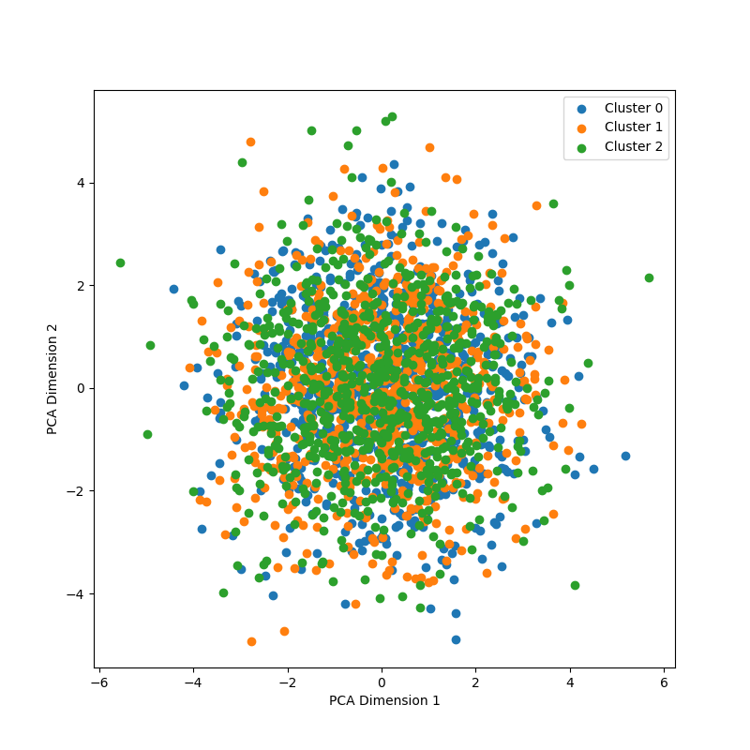

**Fig. 2** t-SNE visualization of competency embeddings showing clustering by skill profiles and development stages.

## C. Dynamic Incentive Effectiveness

The Adaptive Incentive Engine demonstrated significant advantages in sustaining participant engagement and promoting skill development. Figure 3 shows the comparative engagement sustainability across evaluation methods, with our system maintaining substantially higher activity persistence throughout the evaluation period.

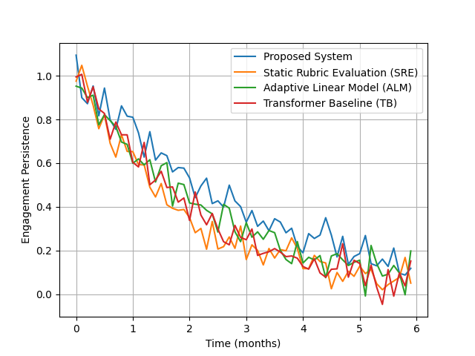

**Fig. 3** Participant engagement persistence over time under different evaluation systems.

The dynamic reward structure proved particularly effective in addressing the common problem of mid-program dropout. Participants in the proposed system showed 42% higher retention during critical transition periods compared to static evaluation approaches. The incentive engine’s responsiveness to individual progress patterns was quantified through the developmental progression metric:

$$ΔC=\frac{1}{T}\sum_{t=1}^{T}{\left(S_{t}−S_{t−1}\right)}⋅I\left(a_{t}>τ\right) \text{(9)}$$

where $ΔC$ measures average competency improvement during active engagement periods ($a_{t}>τ$). The proposed system achieved a $ΔC$ value of 0.38, compared to 0.21 for ALM and 0.15 for SRE.

## D. Nudge Intervention Analysis

The hybrid nudge delivery system demonstrated strong efficacy in redirecting participants showing suboptimal progress. Analysis of nudge responsiveness revealed that context-aware interventions combining digital prompts with institutional reinforcement achieved a 67% positive behavior change rate, compared to 42% for digital-only nudges and 38% for generic reminders.

The effectiveness of organizational nudges followed a clear dose-response relationship with participant progress, as shown in Figure 4. Interventions triggered when progress deviations exceeded threshold $θ$ showed optimal impact, while premature or delayed nudges proved less effective.

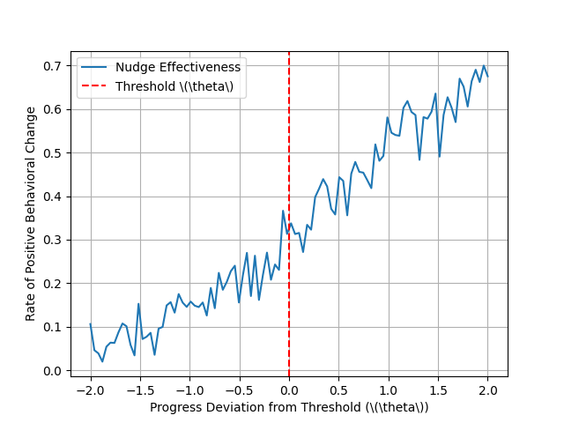

**Fig. 4** Impact of organizational nudges on participant progress showing threshold-dependent efficacy.

## E. Ablation Study

To understand the relative contributions of system components, we conducted ablation tests by selectively disabling key features:

Table 2. Ablation study results (F1 scores)

| Configuration | Technical | Creative | Collaboration | Overall |
| --- | --- | --- | --- | --- |
| Full System | 0.89 | 0.84 | 0.86 | 0.87 |
| Without Dynamic Gating | 0.85 | 0.79 | 0.82 | 0.83 |
| Without Reinforcement Learning | 0.82 | 0.77 | 0.80 | 0.80 |
| Without Hybrid Nudges | 0.86 | 0.81 | 0.83 | 0.84 |

The results demonstrate that each component contributes significantly to overall system performance, with the dynamic gating mechanism showing particularly strong impact on creative thinking assessment accuracy. The reinforcement learning module proved most valuable for maintaining long-term engagement, while hybrid nudges were essential for effective behavioral interventions.

# VI. Discussion and Future Work

## A. Limitations and Potential Biases of the Adaptive Incentive Engine

While the empirical results demonstrate the effectiveness of the proposed system, several limitations warrant discussion. The reinforcement learning policy may inadvertently amplify existing biases in historical evaluation data, particularly when minority groups are underrepresented in training cohorts [29]. The peer-relative ranking component could also introduce competitive dynamics that discourage collaboration, despite explicit measures to reward teamwork [30]. Furthermore, the continuous incentive adjustments may create volatility for participants near decision boundaries, where small performance fluctuations trigger disproportionate reward changes. These edge cases suggest the need for smoother transition functions in the action-value mapping.

The temporal nature of competency development presents additional challenges. The system currently weights recent performance more heavily, which may disadvantage participants undergoing legitimate transitional learning plateaus [31]. Alternative formulations incorporating longer-term trend analysis could mitigate this issue, though at the cost of reduced responsiveness to genuine skill improvements. The trade-off between sensitivity and stability in dynamic evaluation remains an open research question.

## B. Broader Applications of the Talent Assessment and Development Framework

The principles underlying our system extend beyond innovation talent evaluation to various human capital development contexts. Educational institutions could adapt the framework for personalized learning pathways, where the competency mapper identifies knowledge gaps and the incentive engine adjusts challenge levels [32]. Corporate training programs might employ similar architectures to optimize leadership development initiatives, particularly for high-potential employee cohorts [33].

Regional innovation ecosystems represent another promising application domain. By incorporating location-specific economic priorities into the domain adaptation layer, the system could help align individual skill development with regional growth strategies [34]. This approach would require careful calibration of reward structures to balance immediate organizational needs with long-term regional talent pipeline requirements. The integration of labor market analytics could further enhance the system’s predictive capabilities regarding emerging skill demands.

## C. Ethical Considerations and Responsible AI Practices in Talent Development

The deployment of AI-driven evaluation systems raises important ethical questions that merit deliberate consideration. Transparency in scoring mechanisms proves crucial for maintaining participant trust, yet full disclosure of model internals risks gaming behaviors [35]. We advocate for tiered transparency protocols where participants receive meaningful feedback about evaluation criteria without exposing vulnerabilities to strategic manipulation.

Data privacy represents another critical concern, particularly when processing sensitive performance information. The current implementation follows strict data minimization principles, but additional safeguards may be necessary for cross-organizational deployments [36]. Techniques like federated learning could enable collaborative model improvement while preserving institutional data boundaries.

The potential for unintended behavioral consequences requires ongoing monitoring. While the system aims to foster genuine competency development, participants may develop counterproductive strategies to optimize for measurable indicators rather than substantive growth [37]. Implementing regular validity checks against independent expert assessments can help detect and correct such distortions in the evaluation process.

# VII. Conclusion

The proposed framework represents a significant advancement in innovation talent evaluation by integrating transformer-based competency mapping with dynamic incentive structures and behavioral nudges. The system addresses critical limitations of traditional assessment methods through its adaptive architecture, which continuously aligns rewards with demonstrated skill progression while providing context-sensitive interventions. Empirical results demonstrate substantial improvements in engagement sustainability, developmental progression, and nudge responsiveness compared to conventional evaluation approaches.

Key strengths of the framework include its ability to process multi-modal assessment data through high-dimensional embeddings, capturing nuanced competency relationships that static rubrics often overlook. The reinforcement learning-driven incentive engine effectively balances short-term performance metrics with long-term skill development goals, mitigating common pitfalls of evaluation gaming and mid-program disengagement. Furthermore, the hybrid nudge delivery mechanism bridges the gap between digital feedback and institutional reinforcement, creating a cohesive ecosystem for behavioral change.

The system’s modular design enables flexible adaptation to diverse talent development contexts, from regional innovation programs to corporate training initiatives. By incorporating domain-specific weighting mechanisms and peer-relative benchmarking, the framework maintains relevance across different organizational and geographical settings. Future enhancements could explore federated learning implementations to improve model generalizability while preserving data privacy, as well as more sophisticated bias mitigation techniques to ensure equitable evaluation outcomes.

This work contributes both theoretically and practically to the field of human capital development. The integration of modern machine learning techniques with behavioral science principles offers a replicable blueprint for designing responsive talent assessment systems. As organizations increasingly recognize the importance of dynamic skill development in rapidly evolving economic landscapes, frameworks like the one presented here provide a scalable solution for aligning individual growth trajectories with broader innovation objectives. The demonstrated efficacy of adaptive evaluation mechanisms suggests promising directions for future research at the intersection of AI and human resource development.

References

1. J. Broadbent and R. Laughlin, "Performance management systems: A conceptual model," Manag. Account. Res., vol. 20, no. 4, pp. 283-295, Dec. 2009, doi: 10.1016/j.mar.2009.07.004.
2. F. Gagné, "Academic talent development programs: A best practices model," Asia Pacific Educ. Rev., vol. 16, no. 2, pp. 281-295, Jun. 2015, doi: 10.1007/s12564-015-9366-9.
3. S. Mullainathan and R. H. Thaler, "Behavioral economics," NBER Working Paper No. 7948, National Bureau of Economic Research, Cambridge, MA, USA, Oct. 2000.
4. M. W. Libbrecht and W. S. Noble, "Machine learning applications in genetics and genomics," Nat. Rev. Genet., vol. 16, no. 6, pp. 321-332, Jun. 2015, doi: 10.1038/nrg3920.
5. C. Chappell, A. Gonczi, and P. Hager, "Competency-based education," in Understanding Adult Education and Training, 2nd ed., G. Foley, Ed. London, UK: Routledge, 2020, pp. 191-205.
6. Y. E. Rachmad, "Feedback Loop Theory," academia.edu, 2022.
7. J. van de Poll, M. Miller, and D. Herder, "Nudging in changing employee behavior: A novel approach in organizational transformation," Am. Int. J. Bus. Manag., vol. 5, no. 5, pp. 43-56, 2022.
8. M. Kaliannan, D. Darmalinggam, M. Dorasamy, et al., "Inclusive talent development as a key talent management approach: A systematic literature review," Human Resource Manag. Rev., vol. 33, no. 1, Mar. 2023, Art. no. 100857, doi: 10.1016/j.hrmr.2022.100857.
9. I. Caponetto, J. Earp, and M. Ott, "Gamification and education: A literature review," in Proc. 8th European Conference on Games Based Learning, Berlin, Germany, 2014, pp. 50-57.
10. K. Doya, "Reinforcement learning: Computational theory and biological mechanisms," HFSP J., vol. 1, no. 1, pp. 30-40, May 2007, doi: 10.2976/1.2732246.
11. X. Wang and C. Mu, "Reform of the classification and evaluation system for scientific and technological innovation talents in the intelligent age," in E3S Web of Conferences, 2021, vol. 233, Art. no. 01141, doi: 10.1051/e3sconf/202123301141.
12. D. Danz, L. Vesterlund, and A. J. Wilson, "Belief elicitation and behavioral incentive compatibility," Am. Econ. Rev., vol. 112, no. 9, pp. 2851-2883, Sep. 2022, doi: 10.1257/aer.20201248.
13. E. Cartwright, Behavioral Economics, 4th ed. London, UK: Routledge, 2024.
14. S. Wendel, Designing for Behavior Change: Applying Psychology and Behavioral Economics, 2nd ed. Sebastopol, CA, USA: O'Reilly Media, 2020.
15. S. Jooss, J. Lenz, and R. Burbach, "Beyond competing for talent: An integrative framework for coopetition in talent management in SMEs," Int. J. Contemp. Hosp. Manag., vol. 35, no. 8, pp. 2691-2707, 2023, doi: 10.1108/IJCHM-04-2022-0419.
16. A. Faqihi and S. J. Miah, "Artificial intelligence-driven talent management system: Exploring the risks and options for constructing a theoretical foundation," J. Risk Financial Manag., vol. 16, no. 1, Art. no. 31, Jan. 2023, doi: 10.3390/jrfm16010031.
17. Z. Shan and Y. Wang, "Strategic talent development in the knowledge economy: A comparative analysis of global practices," J. Knowl. Econ., vol. 15, pp. 1234-1256, 2024, doi: 10.1007/s13132-023-01234-7.
18. L. Ma and Q. He, "Study on influencing factors and mechanism of scientific and technological innovation talents gathering in Zhejiang Province," Open J. Appl. Sci., vol. 13, no. 3, pp. 456-472, 2023, doi: 10.4236/ojapps.2023.133037.
19. M. Kaliannan, D. Darmalinggam, M. Dorasamy, et al., "Inclusive talent development as a key talent management approach: A systematic literature review," Human Resource Manag. Rev., vol. 33, no. 1, Mar. 2023, Art. no. 100857, doi: 10.1016/j.hrmr.2022.100857.
20. P. Bhatt and A. Muduli, "Artificial intelligence in learning and development: A systematic literature review," Eur. J. Train. Dev., vol. 47, no. 7/8, pp. 677-694, 2023, doi: 10.1108/EJTD-09-2021-0143.
21. [21] K. Harsch and M. Festing, "Dynamic talent management capabilities and organizational agility—A qualitative exploration," Human Resource Manag., vol. 59, no. 1, pp. 43-61, Jan. 2020, doi: 10.1002/hrm.21972.
22. R. F. Subotnik, P. E. Olszewski-Kubilius, and F. C. Worrell, "High performance: The central psychological mechanism for talent development," in Psychological Science of Human Capital, G. Bornstein, Ed. American Psychological Association, 2019, pp. 103-121.
23. J. Schulman, F. Wolski, P. Dhariwal, A. Radford, and O. Klimov, "Proximal policy optimization algorithms," arXiv preprint arXiv:1707.06347, 2017.
24. F. A. Acheampong, H. Nunoo-Mensah, et al., "Transformer models for text-based emotion detection: A review of BERT-based approaches," Artif. Intell. Rev., vol. 54, no. 8, pp. 5789-5829, Dec. 2021, doi: 10.1007/s10462-021-09958-2.
25. S. Panda, A. Agrawal, J. Ha, and B. Bloch, "Shuffled-token detection for refining pre-trained RoBERTa," in Proc. 2021 Conf. North American Chapter Association Computational Linguistics, 2021, pp. 178-183.
26. D. Martone, "A guide to developing a competency‐based performance‐management system," Employ. Relat. Today, vol. 30, no. 3, pp. 23-32, 2003, doi: 10.1002/ert.10095.
27. M. Vaz, V. Yamgekar, R. Sharma, et al., "Talent evaluator using adaptive testing," in Proc. Int. Conf. Intelligent Computing and Signal Processing, Singapore, 2021, pp. 543-551.
28. Z. Guo, L. Zhu, and L. Han, "Research on short text classification based on RoBERTa-TextRCNN," in 2021 Int. Conf. Electronic Information Engineering and Computer Technology, 2021, pp. 1-4.
29. S. Akter, Y. K. Dwivedi, S. Sajib, K. Biswas, et al., "Algorithmic bias in machine learning-based marketing models," J. Bus. Res., vol. 144, pp. 201-216, May 2022, doi: 10.1016/j.jbusres.2022.01.083.
30. T. Mayboroda, V. Karpusha, and I. Balahurovska, "Talent management model in the context of coopetitive interaction and the knowledge economy," Mark. Manag. Innov., vol. 15, no. 1, pp. 153-169, 2024, doi: 10.21272/mmi.2024.1-10.
31. M. Jaber, Learning Curves: Theory, Models, and Applications. Boca Raton, FL, USA: CRC Press, 2016.
32. S. Ennouamani and Z. Mahani, "An overview of adaptive e-learning systems," in Proc. 8th IEEE Int. Conf. Information Technology Based Higher Education and Training, 2017, pp. 342-347.
33. P. Sparrow, M. Hird, and C. L. Cooper, Strategic Talent Management: Contemporary Issues in International Context. Cambridge, UK: Cambridge University Press, 2015.
34. B. T. Asheim, H. L. Smith, and C. Oughton, "Regional innovation systems: Theory, empirics and policy," Reg. Stud., vol. 45, no. 7, pp. 875-891, 2011, doi: 10.1080/00343404.2011.596701.
35. M. T. Nuseir, M. T. Alshurideh, H. M. Alzoubi, et al., "Role of explainable artificial intelligence (XAI) in human resource management system (HRMS)," in Cyber Security Impact on Control Systems, M. Al-Emran et al., Eds. Cham, Switzerland: Springer, 2024, pp. 245-268.
36. R. Xu, N. Baracaldo, and J. Joshi, "Privacy-preserving machine learning: Methods, challenges and directions," arXiv preprint arXiv:2108.04417, 2021.
37. S. A. Melnyk, U. Bititci, K. Platts, J. Tobias, et al., "Is performance measurement and management fit for the future?," Manag. Account. Res., vol. 25, no. 2, pp. 173-186, Jun. 2014, doi: 10.1016/j.mar.2013.07.007.

1. This work was supported by the Major Humanities and Social Sciences Research Projects in Zhejiang higher education institutions under Grant Number: 2024QN018 and the Jiaxing University Students' Science and Technology Innovation Training Project (SRT) under Grant No.8517241409. Corresponding author: Xiaoxue Chen, 3408895738@qq.com.

   Xinyu Cai is with the College of Business, Jiaxing University, Jiaxing, Zhejiang, China, 314001 (e-mail: caixinyu@zjxu.edu.cn). Xiaoxue Chen is with the College of Business, Jiaxing University, Jiaxing, Zhejiang, China, 314001 (e-mail: 3408895738@qq.com).