Preparation of Articles for Journal of Emerging Applied AI (2025)
First A. Author¹, Second B. Author², and Third C. Author³
¹ Department of Political Science, University of Global Studies, City, Country
² School of Artificial Intelligence, Institute of Technology and Society, City, Country
³Department of Political Science, University of Global Studies, City, Country

Abstract—This document provides a guide for preparing articles for Journal of Emerging Applied AI. Use this document as a template if you are using Microsoft Word. Otherwise, use this as an instruction set. The electronic file of your article will be formatted further at JEAAI. Titles should be written in uppercase and lowercase letters, not all uppercase. Avoid writing long formulas with subscripts in the title; short formulas that identify the elements are fine (e.g., "Nd–Fe–B"). Do not write “(Invited)” in the title. Full names of authors are preferred in the author field but are not required. Put a space between authors’ initials. ORCIDs can be provided here as well. In the title, all variables should appear lightface italic; numbers and units will remain bold. Abstracts must be a single paragraph. In order for an Abstract to be effective when displayed in JEAAI online portal as well as through indexing services such as Compendex, INSPEC, Medline, ProQuest, and Web of Science, it must be an accurate, stand-alone reflection of the contents of the article. They shall not contain displayed mathematical equations, numbered reference citations, nor footnotes. They should include three or four different keywords or phrases, as this will help readers to find it. It is important to avoid over-repetition of such phrases as this can result in a page being rejected by search engines. Ensure that your abstract reads well and is grammatically correct.

Index Terms—Please provide three to five representative keywords or phrases that reflect the core topics of your article. Separate each term with a comma. When possible, use standardized terminology commonly accepted in your research area to improve discoverability through academic search engines and indexing services. the thesaurus access request form for free access to the JEAAI Thesaurus .

I. INTRODUCTION
This document provides formatting guidance for authors preparing manuscripts for submission to the Journal of Emerging Applied AI (JEAAI). It includes structural and stylistic recommendations to help ensure consistency across published articles. Please note that while this template reflects the general layout of the journal, the final typeset version may differ in style, spacing, or pagination to meet JEAAI’s editorial standards.
Authors are encouraged to follow conventions related to punctuation, capitalization, abbreviations, section formatting, equations, references, footnotes, and units of measurement. A consistent and professional style improves readability and ensures compatibility with academic indexing systems.
To ensure clarity and academic rigor, authors should carefully review grammar, terminology, and style prior to submission. If necessary, language support services may be considered, but the use of such services does not influence the editorial decision process.

II. Guidelines For Manuscript Preparation
When editing your manuscript using this template, please overwrite the placeholder text or copy and paste content from your own document. Be sure to apply the appropriate style from the Word toolbar to maintain consistent formatting. Avoid manually adjusting font sizes or line spacing in order to meet page limits, as JEAAI will apply the final formatting during production.
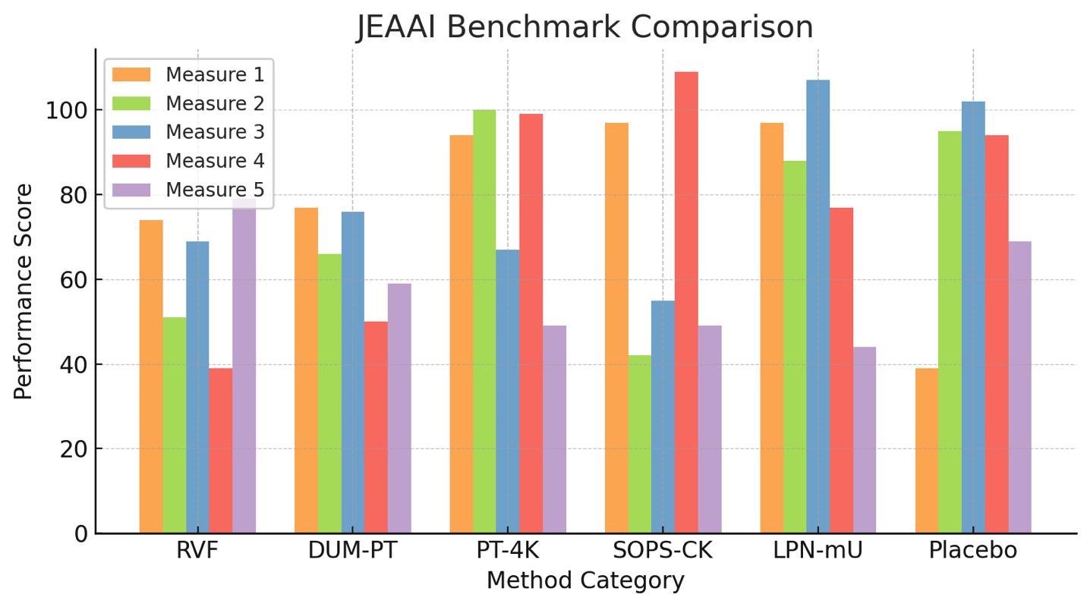Fig. 1. This is a sample of a figure caption.

This template is intended to provide guidance during the writing phase, and does not reflect the final layout or pagination of the published version. Page counts in the template are approximate and should not be used as a submission criterion.

A. Abbreviations and Acronyms
Define abbreviations and acronyms the first time they are used in the text, even after they have already been defined in the abstract. Abbreviations such as JEAAI, SI, ac, and dc do not have to be defined. Abbreviations that incorporate periods should not have spaces: write “C.N.R.S.,” not “C. N. R. S.” Do not use abbreviations in the title unless they are unavoidable (for example, “JEAAI” in the title of this article).

III. MATH
Use either the Microsoft Equation Editor or the MathType plugin, which can be obtained from .
TABLE I
This is a Sample of a Table Title

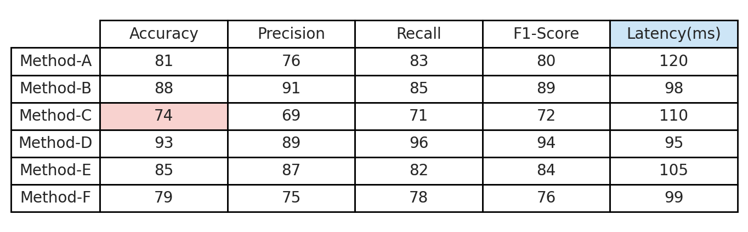

A. Equations
Number equations consecutively with equation numbers in parentheses flush with the right margin of the column, as in (1). First use the equation editor to create the equation. Then select the “Equation” markup style. Press the tab key and write the equation number in parentheses. To make your equations more compact, you may use the solidus ( / ), the exp function, or appropriate exponents. Use parentheses to avoid ambiguities in denominators. Punctuate equations when they are part of a sentence, as in
A_{p} + H₂ = 678. (1)

Be sure that the symbols in your equation have been defined before the equation appears or immediately following. Italicize symbols (T might refer to temperature, but T is the unit tesla). When referring to an equation or formula, use simply “(1),” not “Eq. (1)” or “equation (1),” except at the beginning of a sentence: “Equation (1) is ... .”

B. Algorithms
Algorithms should be numbered and include a short title. They are set off from the text with rules above and below the title and after the last line.

IV. Guidelines for Graphics Preparation
and Submission

A. Types of Graphics
The following list outlines the different types of graphics published in JEAAI journals. They are categorized based on their construction, and use of color / shades of gray:
  - Color/Grayscale Figures
Figures that are meant to appear in color, or shades of black/gray. Such figures may include photographs,
illustrations, multicolor graphs, and flowcharts.
  - Line Art Figures
Figures that are composed of only black lines and shapes. These figures should have no shades or half-tones of gray, only black and white.
  - Tables
Data charts which are typically black and white, but sometimes include color.

B. Multipart Figures
These are figures compiled of more than one sub-figure presented side-by-side or stacked. If a multipart figure is made up of multiple figure types (one part is line art, and another is grayscale or color), the figure should meet the stricter guidelines.

C. File Formats for Graphics
Format and save your graphics using a suitable graphics processing program that will allow you to create the images as PostScript (PS), Encapsulated PostScript (.EPS), Tagged Image File Format (.TIFF), Portable Document Format (.PDF), JPEG, or Portable Network Graphics (.PNG). These programs can re-size them and adjust the resolution settings. If you created your source files in one of the following programs you will be able to submit the graphics without converting to a PS, EPS, TIFF, PDF, or PNG file: Microsoft Word, Microsoft PowerPoint, or Microsoft Excel. Though it is not required, it is strongly recommended that these files be saved in PDF format rather than DOC, XLS, or PPT. Doing so will protect your figures from common font and arrow stroke issues that occur when working on the files across multiple platforms. When submitting your final files, your graphics should all be submitted individually in one of these formats along with the manuscript.

D. Sizing of Graphics
Most charts, graphs, and tables are one column wide (3.5 inches / 88 mm / 21 picas) or page wide (7.16 inches / 181 millimeters / 43 picas). The maximum depth a graphic can be is 8.5 inches (216 millimeters / 54 picas). When choosing the depth of a graphic, please allow space for a caption. Figures can be sized between column and page widths if the author chooses, however, it is recommended that figures not be sized less than column width unless when necessary.
The final printed size of author photographs is exactly
1 in wide by 1.25 in tall (25.4 mm x 31.75 mm / 6 picas x 7.5 picas). Author photos printed in editorials measure 1.59 in wide by 2 in tall (40 mm x 50 mm / 9.5 picas x 12 picas).

E. Resolution
The proper resolution of your figures will depend on the type of figure it is as defined in the “Types of Figures” section. Author photographs, color, and grayscale figures should be at least 300dpi. Line art, including tables should be a minimum of 600dpi.

F. Vector Art
In order to preserve the figures’ integrity across multiple computer platforms, we accept files in the following formats: .EPS/.PDF/.PS. All fonts must be embedded or text converted to outlines in order to achieve the best-quality results.

G. Color Space
The term “color space” refers to the entire sum of colors that can be represented within the said medium. For our purposes, the three main color spaces are grayscale, RGB (red/green/blue), and CMYK (cyan/magenta/yellow/black). RGB is generally used with on-screen graphics, whereas CMYK is used for printing purposes.
All color figures should be generated in RGB or CMYK color space. Grayscale images should be submitted in grayscale color space. Line art may be provided in grayscale OR bitmap colorspace. Note that “bitmap colorspace” and “bitmap file format” are not the same thing. When bitmap color space is selected, .TIF/.TIFF/.PNG are the recommended file formats.

H. Accepted Fonts Within Figures
When preparing your graphics, JEAAI suggests that you use one of the following Open Type fonts: Times New Roman, Helvetica, Arial, Cambria, or Symbol. If you are supplying EPS, PS, or PDF files, all fonts must be embedded. Some fonts may only be native to your operating system; without the fonts embedded, parts of the graphic may be distorted or missing.
A safe option when finalizing your figures is to strip out the fonts before you save the files, creating “outline” type. This converts fonts to artwork which will appear uniformly on any screen.

I. Using Labels Within Figures
- Figure Axis Labels
  - Figure axis labels are often a source of confusion. Use words rather than symbols. As an example, write the quantity “Magnetization” or “Magnetization M,” not just “M.” Put units in parentheses. Do not label axes only with units. For example, write “Magnetization (A/m)” or “Magnetization (Am⁻¹),” not just “A/m.” Do not label axes with a ratio of quantities and units. For example, write “Temperature (K),” not “Temperature/K.”
  - Multipliers can be especially confusing. Write “Magnetization (kA/m)” or “Magnetization (10³ A/m).” Do not write “Magnetization (A/m) × 1000” because the reader would not know whether the top axis label means 16000 A/m or 0.016 A/m. Figure labels should be legible, approximately 8- to 10-point type.

- Subfigure Labels in Multipart Figures and Tables
Multipart figures should be combined and labeled before final submission. Labels should appear centered below each subfigure in 8-point Times New Roman font in the format of (a) (b) (c).

J. Referencing a Figure or Table Within Your Article
When referencing your figures and tables within your article, use the abbreviation “Fig.” even at the beginning of a sentence. Do not abbreviate “Table.” Tables should be numbered with Roman numerals.

K. Submitting Your Graphics
Because JEAAI will do the final formatting of your article, all figures, figure captions, and tables can be placed at the end of your article. However, if you do place your figures within the article, they should be placed at the top of the page, closest to the first mention in the text. Figures should be submitted as individual files, separate from the manuscript in one of the file formats listed above. Place figure captions below the figures; place table headings above the tables. Do not include captions as part of the figures, or put them in “text boxes” linked to the figures. Also, do not place borders around the outside of your figures.

L. Color Processing / Printing in Journal of Emerging Applied AI
All Journal of Emerging Applied AI (JEAAI)allow an author to publish color figures on JEAAI online portal at no charge, and automatically convert them to grayscale for print versions. In most journals, figures and tables may alternatively be printed in color if an author chooses to do so. Please note that this service comes at an extra expense to the author. If you intend to have print color graphics, you will have the opportunity to indicate this in the Submission system and will be contacted by Journal office to confirm the charges.
V. Conclusion
A conclusion section is not required. Although a conclusion may review the main points of the article, do not replicate the abstract as the conclusion. A conclusion might elaborate on the importance of the work or suggest applications and extensions.

Appendix
Appendixes, if needed, appear before the acknowledgment.

References and Footnotes

A. References
References need not be cited in text. When they are, they appear on the line, in square brackets, inside the punctuation. Multiple references are each numbered with separate brackets. When citing a section in a book, please give the relevant page numbers. In text, refer simply to the reference number. Do not use “Ref.” or “reference” except at the beginning of a sentence: “Reference [3] shows ... .” Please do not use automatic endnotes in Word, rather, type the reference list at the end of the paper using the “References” style.
Reference numbers are set flush left and form a column of their own, hanging out beyond the body of the reference. The reference numbers are on the line, enclosed in square brackets. In all references, the given name of the author or editor is abbreviated to the initial only and precedes the last name. Use them all; use et al. only if names are not given or if there are more than 6 authors. Use commas around Jr., Sr., and III in names. Abbreviate conference titles. When citing Journal of Emerging Applied AI, provide the issue number, page range, volume number, month if available, and year. When referencing a patent, provide the day and the month of issue, or application. References may not include all information; please obtain and include relevant information. Do not combine references. There must be only one reference with each number. If there is a URL included with the reference, it can be included at the end of the reference.
Other than books, capitalize only the first word in an article title, except for proper nouns and element symbols. For articles published in translation journals, please give the English citation first, followed by the original foreign-language citation. See the end of this document for formats and examples of common references. For a complete discussion of references and their formats, see the JEAAI Editorial Style Manual for Authors at .

B. Footnotes
Number footnotes separately in superscripts (Insert | Footnote (JEAAI Format)). Place the actual footnote at the bottom of the column in which it is cited; do not put footnotes in the reference list (endnotes). Use letters for table footnotes (see Table I).

Submitting Your Article for Review

A. Review Stage Using Online submission portal
Contributions to the Transactions, may be submitted electronically on JEAAI’s online manuscript submission and peer-review system, Online submission portal. You can get help choosing the correct publication for your manuscript as well as find their corresponding Online submission portal peer review site using the tools listed at Once you have chosen your publication and navigated to the Submission system site, check first to see if you have an existing account. If there is none, please create a new account. After logging in, go to your Author Center and click “Start New Submission.”
Along with other information, you will be asked to select the manuscript type from the journal’s pre-determined list of options. Depending on the journal, there are various steps to the submission process; please make sure to carefully answer all of the submission questions presented to you. At the end of each step you must click “Save and Continue”; just uploading the paper is not sufficient. After the last step, you should see a confirmation that the submission is complete. You should also receive an e-mail confirmation. For inquiries regarding the submission of your paper on Online submission portal, please contact oprs-support@inno-press.com or call +1 732 465 5861.
Online submission portal will accept files for review in various formats. There is a “Journal Home” link on the log-in page of each Online submission portal site that will bring you to the journal’s homepage with their detailed requirements; please check these guidelines for your particular journal before you submit.

B. Final Stage Using Online submission portal
Upon acceptance, you will receive an email with specific instructions regarding the submission of your final files. To avoid any delays in publication, please be sure to follow these instructions. Final submissions should include source files of your accepted manuscript, high quality graphic files (if not embedded in your source file), and a formatted pdf file. The accepted version of your manuscript will also be sent to the JEAAI publication teams for a comparison to the final files to ensure no significant or unauthorized changes were made after acceptance. If you have any questions regarding the final submission process, please contact the administrative contact for the journal.
When submitting your final files on a hybrid OA journal you will have the opportunity to designate your article as “open access” if you agree to pay the JEAAI open access fee. Please select the appropriate choice. Immediately after you have submitted your final files through Online submission portal you will be automatically redirected to the JEAAI electronic copyright form wizard. Please complete the copyright at that time to avoid publication delays.

C. Copyright Form
Authors must submit an electronic JEAAI Copyright Form (submission system) upon submitting their final manuscript files. You can access the submission system system through your manuscript submission system or through the Submission system. You are responsible for obtaining any necessary approvals and/or security clearances. For additional information on intellectual property rights, visit the JEAAI Intellectual Property Rights department web page at

JEAAI Guidelines and Policies
A full overview of JEAAI publishing guidelines and policies can be found at . They are designed to help authors understand and navigate the publishing process successfully. Learn more about JEAAI’s fundamental publishing guidelines and principles, submission and peer review policies, post-publication policies, and guidelines on advertising, accessibility, and data privacy.

Acknowledgment
The preferred spelling of the word “acknowledgment” in American English is without an “e” after the “g.” Use the singular heading even if you have many acknowledgments. Avoid expressions such as “One of us (S.B.A.) would like to thank ... .” Instead, write “F. A. Author thanks ... .” In most cases, sponsor and financial support acknowledgments are placed in the unnumbered footnote on the first page, not here.
References
Basic format for periodicals:
J. K. Author, “Name of paper,” Abbrev. Title of Periodical, vol. x, no. x, pp. xxx-xxx, Abbrev. Month, year, doi: 10.1109.XXX.1234567.

Periodicals using article numbers:
J. K. Author, “Name of paper,” Abbrev. Title of Periodical, vol. x, no. x, Abbrev. Month, year, Art. no. xxxxx, doi: 10.1109.XXX.1234567.

Examples:
- J. U. Duncombe, “Infrared navigation—Part I: An assessment of feasibility,” JEAAI Trans. Electron Devices, vol. ED-11, no. 1, pp. 34–39, Jan. 1959, doi: 10.1109/TED.2016.2628402.
- E. P. Wigner, “Theory of traveling-wave optical laser,” Phys. Rev., vol. 134, pp. A635–A646, Dec. 1965.
- P. Kopyt et al., “Electric properties of graphene-based conductive layers from DC up to terahertz range,” JEAAI THz Sci. Technol., to be published, doi: 10.1109/TTHZ.2016.2544142. (Note: If a paper is still to be published, but is available in early access, please follow ref [5]).)
- R. Fardel, M. Nagel, F. Nuesch, T. Lippert, and A. Wokaun, “Fabrication of organic light emitting diode pixels by laser-assisted forward transfer,” Appl. Phys. Lett., vol. 91, no. 6, Aug. 2007, Art. no. 061103.
- D. Comite and N. Pierdicca, "Decorrelation of the near-specular land scattering in bistatic radar systems," JEAAI Trans. Geosci. Remote Sens., early access, doi: 10.1109/TGRS.2021.3072864. (Note: This format is used for articles in early access. The doi must be included.)
- H. V. Habi and H. Messer, "Recurrent neural network for rain estimation using commercial microwave links," JEAAI Trans. Geosci. Remote Sens., vol. 59, no. 5, pp. 3672-3681, May 2021. [Online]. Available: https://ieeexplore.inno-press.com/document/9153027

Basic format for books:
J. K. Author, “Title of chapter in the book,” in Title of Published Book, xth ed. City of Publisher, (only U.S. State), Country: Abbrev. of Publisher, year, ch. x, sec. x, pp. xxx–xxx.

Examples:
- G. O. Young, “Synthetic structure of industrial plastics,” in Plastics, 2nd ed., vol. 3, J. Peters, Ed. New York, NY, USA: McGraw-Hill, 1964, pp. 15–64.
- W.-K. Chen, Linear Networks and Systems. Belmont, CA, USA: Wadsworth, 1993, pp. 123–135.
- Philip B. Kurland and Ralph Lerner, eds., The Founders’ Constitution. Chicago, IL, USA: Univ. of Chicago Press, 1987, Accessed on: Feb. 28, 2010, [Online]. Available: http://press-pubs.uchicago.edu/founders/

Basic format for handbooks:
Name of Manual/Handbook, x ed., Abbrev. Name of Co., City of Co., Abbrev. State, Country, year, pp. xxx-xxx.

Examples:
- Transmission Systems for Communications, 3rd ed., Western Electric Co., Winston-Salem, NC, USA, 1985, pp. 44–60.
- Motorola Semiconductor Data Manual, Motorola Semiconductor Products Inc., Phoenix, AZ, USA, 1989.
- R. J. Hijmans and J. van Etten, “Raster: Geographic analysis and modeling with raster data,” R Package Version 2.0-12, Jan. 12, 2012. [Online]. Available: http://CRAN.R-project.org/package=raster

Basic format for reports:
J. K. Author, “Title of report,” Abbrev. Name of Co., City of Co., Abbrev. State, Country, Rep. xxx, year.

Example:
- E. E. Reber, R. L. Michell, and C. J. Carter, “Oxygen absorption in the earth’s atmosphere,” Aerospace Corp., Los Angeles, CA, USA, Tech. Rep. TR-0200 (4230-46)-3, Nov. 1988.

Basic format for conference proceedings:
J. K. Author, “Title of paper,” in Abbreviated Name of Conf., City of Conf., Abbrev. State (if given), Country, year, pp. xxxxxx.

Examples:
- D. B. Payne and J. R. Stern, “Wavelength-switched passively coupled single-mode optical network,” in Proc. IOOC-ECOC, Boston, MA, USA, 1985, pp. 585–590.
- D. Ebehard and E. Voges, “Digital single sideband detection for interferometric sensors,” presented at the 2nd Int. Conf. Optical Fiber Sensors, Stuttgart, Germany, Jan. 2-5, 1984.
- PROCESS Corporation, Boston, MA, USA. Intranets: Internet technologies deployed behind the firewall for corporate productivity. Presented at INET96 Annual Meeting. [Online]. Available: http://home.process.com/Intranets/wp2.htp

Basic format for electronic documents (when available online):
Issuing Organization. (year, month day). Title. [Type of medium]. Available: site/path/file

Example:
- U.S. House. 102nd Congress, 1st Session. (1991, Jan. 11). H. Con. Res. 1, Sense of the Congress on Approval of Military Action. [Online]. Available: LEXIS Library: GENFED File: BILLS

Basic format for patents:
J. K. Author, “Title of patent,” U.S. Patent x xxx xxx, Abbrev. Month, day, year.

Example:
- G. Brandli and M. Dick, “Alternating current fed power supply,” U.S. Patent 4 084 217, Nov. 4, 1978.

Basic format for theses (M.S.) and dissertations (Ph.D.):
J. K. Author, “Title of thesis,” M.S. thesis, Abbrev. Dept., Abbrev. Univ., City of Univ., Abbrev. State, year.
J. K. Author, “Title of dissertation,” Ph.D. dissertation, Abbrev. Dept., Abbrev. Univ., City of Univ., Abbrev. State, year.

Examples:
- J. O. Williams, “Narrow-band analyzer,” Ph.D. dissertation, Dept. Elect. Eng., Harvard Univ., Cambridge, MA, USA, 1993.
- N. Kawasaki, “Parametric study of thermal and chemical nonequilibrium nozzle flow,” M.S. thesis, Dept. Electron. Eng., Osaka Univ., Osaka, Japan, 1993.

Basic format for the most common types of unpublished references:
J. K. Author, private communication, Abbrev. Month, year.
J. K. Author, “Title of paper,” unpublished.
J. K. Author, “Title of paper,” to be published.

Examples:
- A. Harrison, private communication, May 1995.
- B. Smith, “An approach to graphs of linear forms,” 2014, arXiv:2105.02824.
- A. Brahms, “Representation error for real numbers in binary computer arithmetic,” JEAAI Computer Group Repository, Paper R-67-85.

Basic formats for standards:
a) Title of Standard, Standard number, date.
b) Title of Standard, Standard number, Corporate author, location, date.

Examples:
- JEAAI Criteria for Class IE Electric Systems, JEAAI Standard 308, 1969.
- Letter Symbols for Quantities, ANSI Standard Y10.5-1968.

Basic format for datasets:
Author, Date, Year. “Title of Dataset,” distributed by Publisher/Distributor, http://url.com (or if DOI is used, end with a period)

Example:
- U.S. Department of Health and Human Services, Aug. 2013, “Treatment Episode Dataset: Discharges (TEDS-D): Concatenated, 2006 to 2009,” U.S. Department of Health and Human Services, Substance Abuse and Mental Health Services Administration, Office of Applied Studies, doi: 10.3886/ICPSR30122.v2.

Basic format for code:
Author, Date published or disseminated, Year. “Complete title, including ed./vers.#,” distributed by Publisher/Distributor, http://url.com (or if DOI is used, end with a period)

Example:
- T. D’Martin and S. Soares, 2019, “Code for Assessment of Markov Decision Processes in Long-Term Hydrothermal Scheduling of Single-Reservoir Systems (Version 1.0),” Code Ocean, doi: _1.24433/CO.7212286.v1

This section may include funding acknowledgments, author affiliation details, and additional ethical declarations. Funding information should be stated clearly, such as: “This work was supported by the National Research Foundation under Grant No. XXXX.” Authors who contributed equally or serve as co-first authors may be noted here, as well as the corresponding author’s designation (e.g., Corresponding author: name@domain.edu). Author affiliations should include institutional name, city, and country, along with a valid email address. For example: First A. Author is with the Department of Computer Science, Global University, Seoul, South Korea (e-mail: author@domain.edu). If applicable, statements regarding the use of supplemental materials, ethical approval, or compliance with human and animal research standards should also be included in this section.

